**TOP CLASS LESSON NOTES TERM I**

**LEARNING AREA 5 (READING)**

**Learning outcome:**

Listening with acuity for information and enjoyment and responding appropriate in a wide range of situation.

**Competence:**

A learner associates sounds with letters

**WEEK 1**

**Activity 1**

Introducing vowel letter sounds.

a e i o u

**Join and form words.**

a-n a-m a-t a-s a-sk

elb egg elf

i---- n i—ll l – f I --- s i--- t

o-n own owl

u-p u-n u-s

**Activity 2**

**Read and raw**

|  |  |  |  |  |
| --- | --- | --- | --- | --- |
| Apple | axe | Ant | Egg | owl |
|  |  |  |  |  |

**Activity 3-4**

**Listen and write**

**Activity 5**

**Match correctly**

a un

e on

i apple

o egg

u it

**WEEK 2-3**

**Introducing consonant letter / sound**

b, c , d, f, g, h, j, k, l, m, n, r, s, t, v, w, x, y

**Activity 1-2**

**Draw pictures for a given sound.**

b c f

g h k

Activity

**Draw pictures for a given sound.**

l m n

d g f

**Activity 3-4**

**Write the first sound for a picture.**

 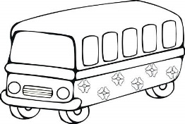 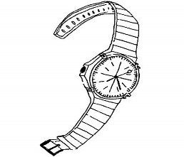 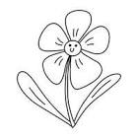

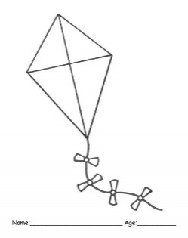 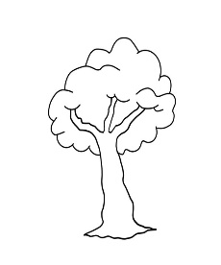 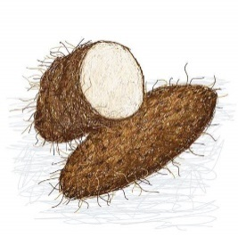 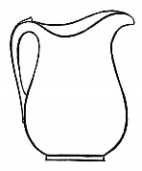

Match sound to picture

Match sound to it’s word

Circle a word for a sound

P t l m

Pencil bed ball mango

Doll table leaf fish

**WEEK 4-5**

**Introducing syllables with sound “a”**

ba ca da fa ga ha ja ka la ma na pa ra

sa ta va wa ya za

**Activity**

**Form word using syllables**

ca-t = cat ma-sk ba-g

pa-st fa-t va-n

ha-t da-d pa-n

la-mb ha-m la-mp

ya-m ca-lf

**Form words using syllables**

m mp

ba la

g mb

t st

ca fa

lf n

**Forming short sentences using the words.**

A cat has a rat

Dan has a fan.

A bag is in a van. Etc

**Other activities**

Read syllables correctly.

Identifying the given syllables.

Match pictures to syllables.

Circle, tick, colour picture for a syllable.

Draw pictures for the syllables.

**Name the pictures.**

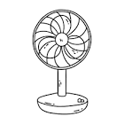 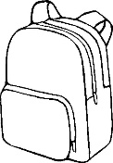 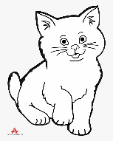  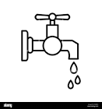

**WEEK 6**

**Introducing syllables with ‘e’ sound**

be de ce fe ge je ke le ma

ne pe se te ve we ye

**Activities**

Reading syllables in the words.

Identifying the correct syllables for picture.

Circle the syllable for a picture.

Form words with ‘e’ sound

Read and draw

**Fill in ‘e’ , read and draw**

n----st v----st

b----lt p-----n

Form sentences using syllable words

Ten eggs in a bag. etc

**WEEK 7**

**Introducing syllables with sound i**

bi di ci fi gi ji mi ni pi ri si ti vi wi

**Join and form words**

si-t ci-ty f-sh wi-ll

si-x bi-t ti-n wi-n

**Join and form words.**

ty____________ g _____________

Ci bi

Ssy__________ t _____________

t_____________ n_____________

Si wi

x _____________ ll _____________

**Write words from the word wheel**

s 1

f in w 2

t b 3

4

5

**Other activities**

**Match and read words**

fi x six

ti sh fish

si n tin

Draw pictures for a given syllable

Listen and write

Ring the correct word for a syllable

Fill in the syllable

**WEEK 8 – 9**

**Introducing of ‘o’ syllable**

bo co do fo go ho mo no po so to lo vo wo

**Forming words**

po-t = pot ho-t = hot

go-t = got do-g = dog

**Form words from the box below.**

ho po

t

go do

**Activities**

Listen and write

Match syllables to picture

Cross the correct syllable for a picture

Name pictures

Form sentences using syllables

**WEEK 10**

This last week will be for revision in all work we have don through the last 9 weeks, for better performance in exams.

**WEEK 6**

Introducing syllables with “e” sound.

be de ce fe ge je ke le me ne pe se te ve we ye

**Activities**

Reading syllables in the words.

Identifying the correct syllables for picture.

Circle the syllable for a picture.

Form words with ‘e’ sound.

Read and draw

**Fill in ‘e’ , read and draw e.g**

n------st v------st b-----lt

p-----n

Form sentences using syllable

Ten eggs in a bag etc

Week 7

Introducing syllables with sound i

Bi di ci fi gi ji mi ni pi ri si ti vi wi

Join and form words.

Si-t ci-ty fi-sh bi-t ti-n wi-n

Join and form words.

Ci ty bi g si t wi n

Ssy t x ll

Write words from the word wheel

Other activities

Match and read words

Fi x six

Ti sh fish

Si n tin

Draw pictures for a given syllable

Listen and write

Ring the correct word for a syllable

Fill in the syllable.

Week 8-9

Introducing of ‘o’ syllable

bo co do fo go ho mo no po so to lo vo wo

Forming words

Po-t = pot ho-t = hot go-t = got do-g = dog

Form words from the word wheel

Activities

Listen and write

Match syllables to picture

Cross the correct syllable for a picture

Name pictures.

Form sentence using syllables

Week 10

This last week will be for revision in all the work we have done through the last weeks for better performance in exams.